**Lab 1**

**10 points**

1. **Open Oracle 11g Express, login and create a new workspace called Lab1. Login to the workspace and execute the query below. Take a screen shot of the result set and paste it in the space below.**

select * from tab;

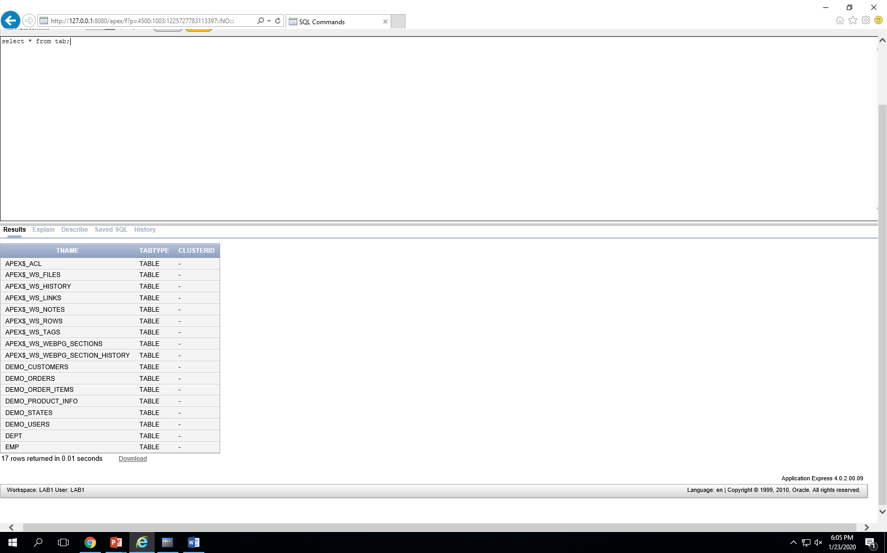

1. **Login to SQL*Plus as the SYSTEM user. Execute the same query. How are the results different?**

Logging in as a DBA or a SYSTEM user gives you access to all the tables in the database where logging in as a regular user will give you access to tables that the DBA has permitted you.

1. **List all the users that are in the database. (Write the SQL Statement here)**

select * from demo_states;

* 1. **Find one of the tables owned by one of the users other than sys or system. Try to query that table. What happens?**

Table or view does not exist. The DBA would have to impersonate as the user to access the table.

* 1. **Login as that user (Lab1). Now try to query that table. What happens?**

The query successfully ran and returned 51 rows.

1. **Query the following catalog tables and explain the difference between them:**
   * 1. **user_tables, user_tab_columns, user_catalog, user_constraints, user_tab_comments**

**The describe command may be helpful here.**

* user_tables: Tables owned by user or in the “USERS” tablespace
* user_tab_columns: Columns in the tables owned by user
* user_catalog: Table types of tables owned by user
* user_constraints: Search condition or constraints assigned to tables owned by user
* user_tab_comments: Comments about tables owned by user

1. **Visit the Administration tab in Oracle 11g Express and find out how many different objects there are in your workspace.**

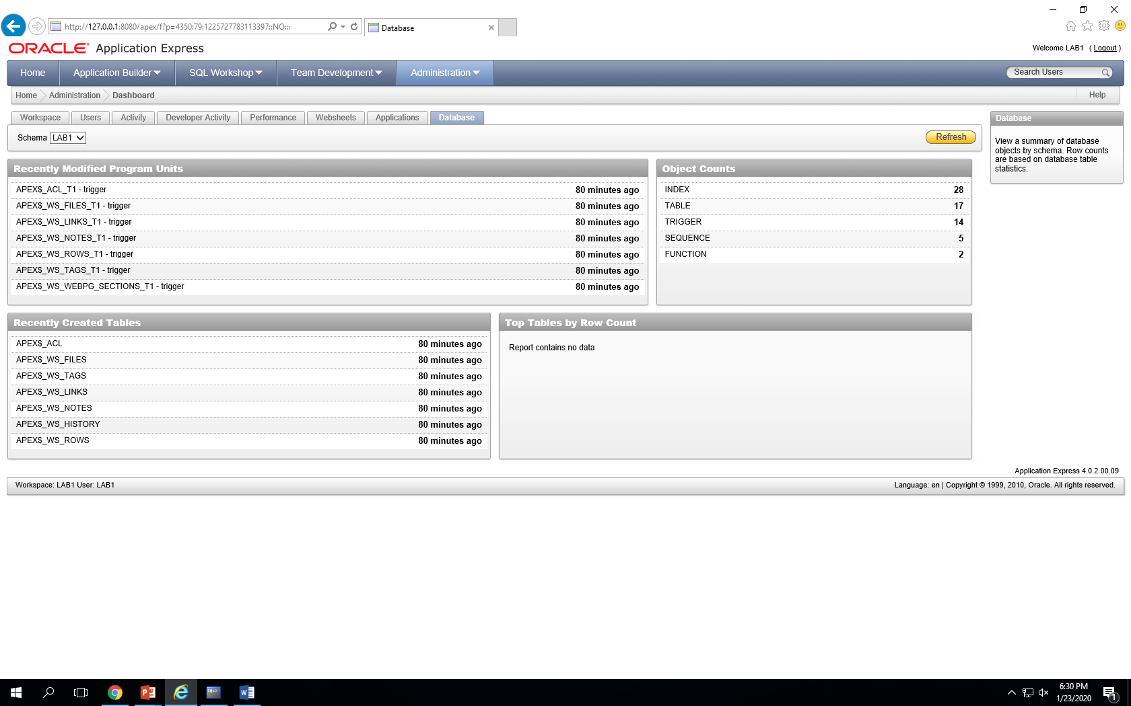

* 66 objects